HERIOT - WATT UNIVERSITY

School of Engineering & Physical Sciences

Mechanical Engineering Laboratory

Arduino Experiments

Introduction: Blink

One of the classic but most important projects for novices is the “blink” project, where you will be connecting a light-emitting diode (an LED) to the Arduino, and programming it to turn off and on.

## Required Components:

* Arduino UNO
* LED
* 330Ω resistor
* Breadboard
* Jumper cables

## Circuit:

Before setting things up, let’s introduce a couple of components.

### LED:

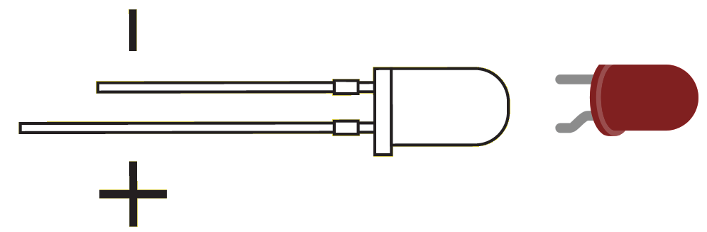

Figure 1: Light Emitting Diodes (LED)

If you are unfamiliar with electronics, the D in LED stands for Diode, which is an electronic component that only allows current in one direction! Therefore it’s important to take note which leg of your LED is the anode (the long leg, positive) and cathode (short leg, negative). Connect the anode (long leg) to the jumper cable coming from pin 13 (or whatever pin you used). Connect the cathode (short leg) to the resistor.

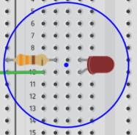

Figure 2: LED in the circuit

### Breadboard:

Breadboards work by having thin strips of copper underneath a covering, with holes in it to grab at the legs of components. If two different components have a leg touching the same strip of copper, they are connected.

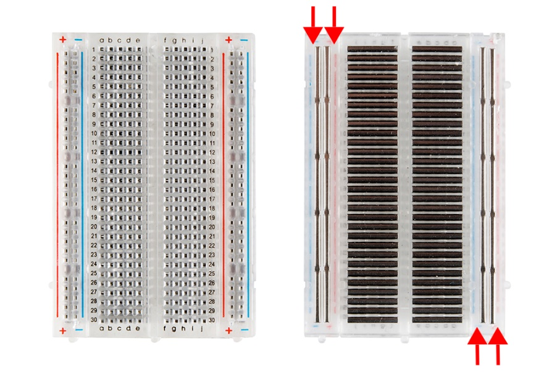

Figure 3: Showing how the slots in breadboards are connected. Note that the horizontal connections do NOT continue over the middle. Image source: learn.sparkfun [2]

Now that we know the components we can set up our Arduino as shown below.

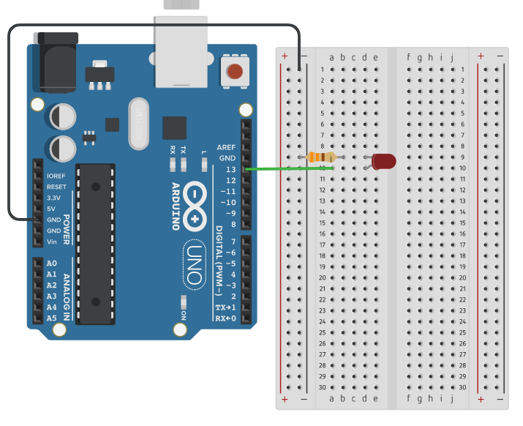

Figure : Basic LED Circuit

## Programming:

Open up the Arduino IDE (Integrated Development Environment) on your computer. This should be installed on university computers, or you can install it on your own laptop by downloading the software from <https://www.arduino.cc/en/Main/Software>.

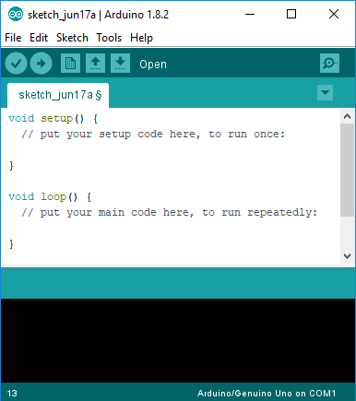

Figure 4: Arduino IDE

If there is already a sketch loaded in your IDE, go to File > New to create a blank sketch.

*\*Open the file called “Blink” in the Arduino folder*

Arduino sketches are broken into two sections, the “setup” and “loop” sections. When the Arduino is powered up, it runs through any code in the “setup” section once, then infinitely loops whatever code is in the “loop” section. Remember that Arduinos use a linear style of programming, meaning they start at the top and work their way down.

Once your sketch is written, connect your Arduino to your computer and click Upload (the right pointing arrow)



Figure 5: Run the code

Once code is uploaded it will use that code until it is overwritten when uploading new code. The Arduino cable is safe to unplug at any moment.

*\*\** *If you can’t connect to the board go to Tools>Port> and select COM#(Arduino/Genuino Uno)*

If you’re lucky, everything should have clicked into place and your LED will be flashing! If the IDE spits out an error saying “problem uploading to board”, try clicking Tools>Port>(your Arduino) and reuploading.

*\*\*\*You can find the Arduino language reference at* <https://www.arduino.cc/reference/en/>

## References:

[1] Arduino, "Blink," 28 July 2015. [Online]. Available: https://www.arduino.cc/en/Tutorial/Blink. [Accessed 23 July 2018].

[2] SparkFun Electronics “How to Use a Breadboard”. [Online]. Available: <https://learn.sparkfun.com/tutorials/how-to-use-a-breadboard/all> [Accessed 17 June 2019].